**Office of the Superintendent**

January 23, 2022

Greetings Everyone,

Now that we have been in school for three weeks following the two week holiday break, I want to provide an update on district operations. We continue to monitor our district level data and will continue to implement in-person instruction for our students. According to the Associated Press, U.S. Education Secretary Miguel Cardona said “We’re doing everything we can to make sure that our children have an opportunity to stay in school. That’s where they need to be, and we know we can do it safely.” I agree with Secretary Cardona and will continue to promote vaccinations and mitigation strategies to keep students and staff safe while in the classroom. We know that our students learn best when they are in the classroom with professional, highly qualified teachers. As always, we continue to monitor the overall conditions in our area while keeping the health and safety of our students, staff, and school community as the number one priority. Our student attendance rates are getting back to pre-pandemic/pre-Omicron variant averages. Listed below is the student attendance data for the entire school district.

| Student Attendance | Monday | Tuesday | Wednesday | Thursday | Friday |
| --- | --- | --- | --- | --- | --- |
| January 3-7, 2022 | 83.57% | 84.76% | 84.20% | 82.97% | 80.75% |
| January 10-14, 2022 | 81.90% | 82.20% | 83.90% | 84.50% | 84.20% |
| January 18-21, 2022 | MLK Jr. Holiday | 90.10% | 91.90% | 92.50% | 93.10% |

With our all hands on deck approach many staff members in the building and central office have assumed different roles since we have been back from the holiday break. I appreciate their hard work and dedication to our students. I am scheduling at least a half day every week to substitute teach in the classroom and provide support to students over the next several weeks. I have asked other central office administrators to do the same. Listed below is our staff attendance data which is also getting back to more of a normal rate when we compare both pre-pandemic and pre-omicron variant conditions.

| **Date:** | **5/16/ 2019** | **5/17/ 2019** | **10/14/ 2021** | **10/15/ 2021** | **11/18/ 2021** | **11/19/ 2021** | **1/3/ 2022** | **1/4/ 2022** | **1/5/ 2022** | **1/6/ 2022** |
| --- | --- | --- | --- | --- | --- | --- | --- | --- | --- | --- |
| **Total Absences: We have approximately 2700 staff members** | 185 | 222 | 153 | 211 | 181 | 258 | 230 | 261 | 288 | 288 |
| **Percentage- Staff Absence** | 6.85% | 8.22% | 5.67% | 7.81% | 6.70% | 9.56% | 8.52% | 9.67% | 10.67% | 10.67% |
| **Date:** | **1/7/ 2022** | **1/10/ 2022** | **1/11/ 2022** | **1/12/ 2022** | **1/13/ 2022** | **1/14/ 2022** | **1/18/ 2022** | **1/19/ 2022** | **1/20/ 2022** | **1/21/ 2022** |
| **Total Absences: we have approximately 2700 staff members** | 304 | 298 | 299 | 292 | 305 | 314 | 221 | 206 | 208 | 202 |
| Percentage-Staff Absence | 11.26% | 11.04% | 11.07% | 10.81% | 11.30% | 11.63% | 8.19% | 7.63% | 7.70% | 7.48% |

[Please click on this link for an article in the Dearborn Schools First Bell publication that references our staff attendance data.](https://firstbell.dearbornschools.org/2022/01/21/district-attendance-improving-for-staff-and-students/)

I would also like to point out that ever since the first case of COVID 19 came to Michigan, Dearborn Public Schools have led the way in protecting staff and students. Please refer to the bullet points on the next page.

* Working with the guidance of county health professionals, the district was the first in the state to close a school in March 2020, two days before the Governor shut down all schools in the state. We were also online for three quarters of the year in 2020-21 when many schools were implementing in person instruction across the county and the state.
* The district purchased special state of the art “BackPack” sanitizing equipment for all schools.
* Throughout the pandemic PPE has been distributed to schools for use by students and staff. I have recently promoted KN-95 masks. We secured over 500,000 KN-95 masks during the pandemic. We are distributing them for staff and students who request the usage of those masks.
* When vaccines were almost impossible to find, Dearborn was one of the first districts to partner with DMC, Henry Ford Health, and Wayne County Health Department to secure thousands of vaccines for staff and then students. Staff members were given paid time off to go and get the vaccine and to recover from any side effects. To date, the District continues to coordinate with local organizations to bring vaccine clinics to schools. Almost 2,200 staff members have provided the district with their vaccine card and hundreds of students have taken part in clinics held in the schools. Many staff members have personally reached out to me to thank the district for providing vaccines to the staff when they were not readily available.
* As school started in the fall of 2021, the district implemented a mask mandate while on school property. A few days later, county health officials issued a similar mask mandate for all schools.
* Since last spring, the district has provided COVID 19 testing in schools. Dearborn Schools has partnered with the state and with two different companies, one Dearborn based, to provide both rapid and PCR testing for students and staff moving forward.

As stated in previous communications, a decision to potentially change to online learning is based on COVID 19 infection rates at the classroom or grade level, then at the school level, and **as a last resort** the district level if necessary. This does not mean that it is certain the district will move to online learning but we need to be prepared to do so if needed. I would also suggest that families prepare and make plans to accommodate their personal needs if their child’s classroom, grade, or school were to move to an on-line learning situation. As always, it is a parent's personal choice to keep their child home.

I want to commend our outstanding staff throughout the district who have worked extremely hard to provide much needed in-person instruction for the benefit of our students. Thank you to everyone who is complying with our mitigation methods. Please wear your mask appropriately covering both your nose and mouth when you enter a Dearborn Public Schools Building. When our staff notice individuals who are not wearing masks properly we will respectively ask them to wear it appropriately. In addition, we will continue to promote the vaccines, boosters, and other mitigation tools that are available. Getting vaccinated is the best way to protect our family, friends and the broader community. [Click Here to see a list of upcoming Vaccine Clinics](https://firstbell.dearbornschools.org/2022/01/14/five-more-vaccination-clinics-set-for-january/) in schools which is a partnership with C-Assist.

We need everyone in the community to do their part as we are doing our part in the schools with the implementation of multiple mitigation strategies to keep our students, staff and the school community safe. Again, thank you to our entire school community for working together as we continue to mitigate the effects of the virus on our schools and the greater Dearborn community.

Sincerely,

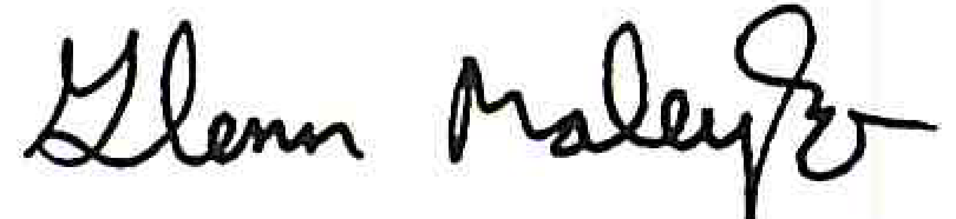

Glenn Maleyko, Ph.D.

Superintendent of Schools

GM/jh/dm/